|  |  |  |  |  |  |
| --- | --- | --- | --- | --- | --- |
| Date | 6-Dec-22 | | | Tester Name | Mohammad Yusuf |
| Environment | Penfax - Test | | | Login used |  |
| Operating System | Select OS | Version: | Update: | | |
| Software Used | Select Software | Version: | Update: | | |
| Select Software | Version: | Update: | | |
| Release version |  | | | | |
| Title | M17 Contributions & DCT | | | | |
| Test Type | Regression | | | | |
| Test Scenario | M17.19 Exporting Error Reports | | | | |
|  |  | | | | |
| Expected Results | Errors Report should show all the errors with details.  Report should be exported to excel and PDF format. | | | | |
| Pass/Fail | Fail | | | JIRA# | N/A |

Describe your steps with screenshots:

1. Log into MEPP DCT and select the Employer from the dropdown.

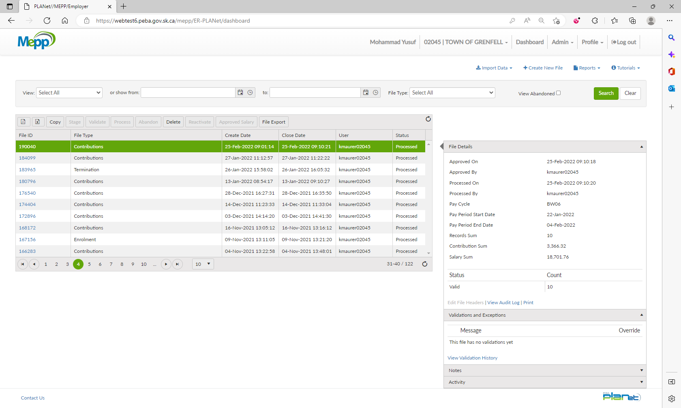

1. Click on any File ID.

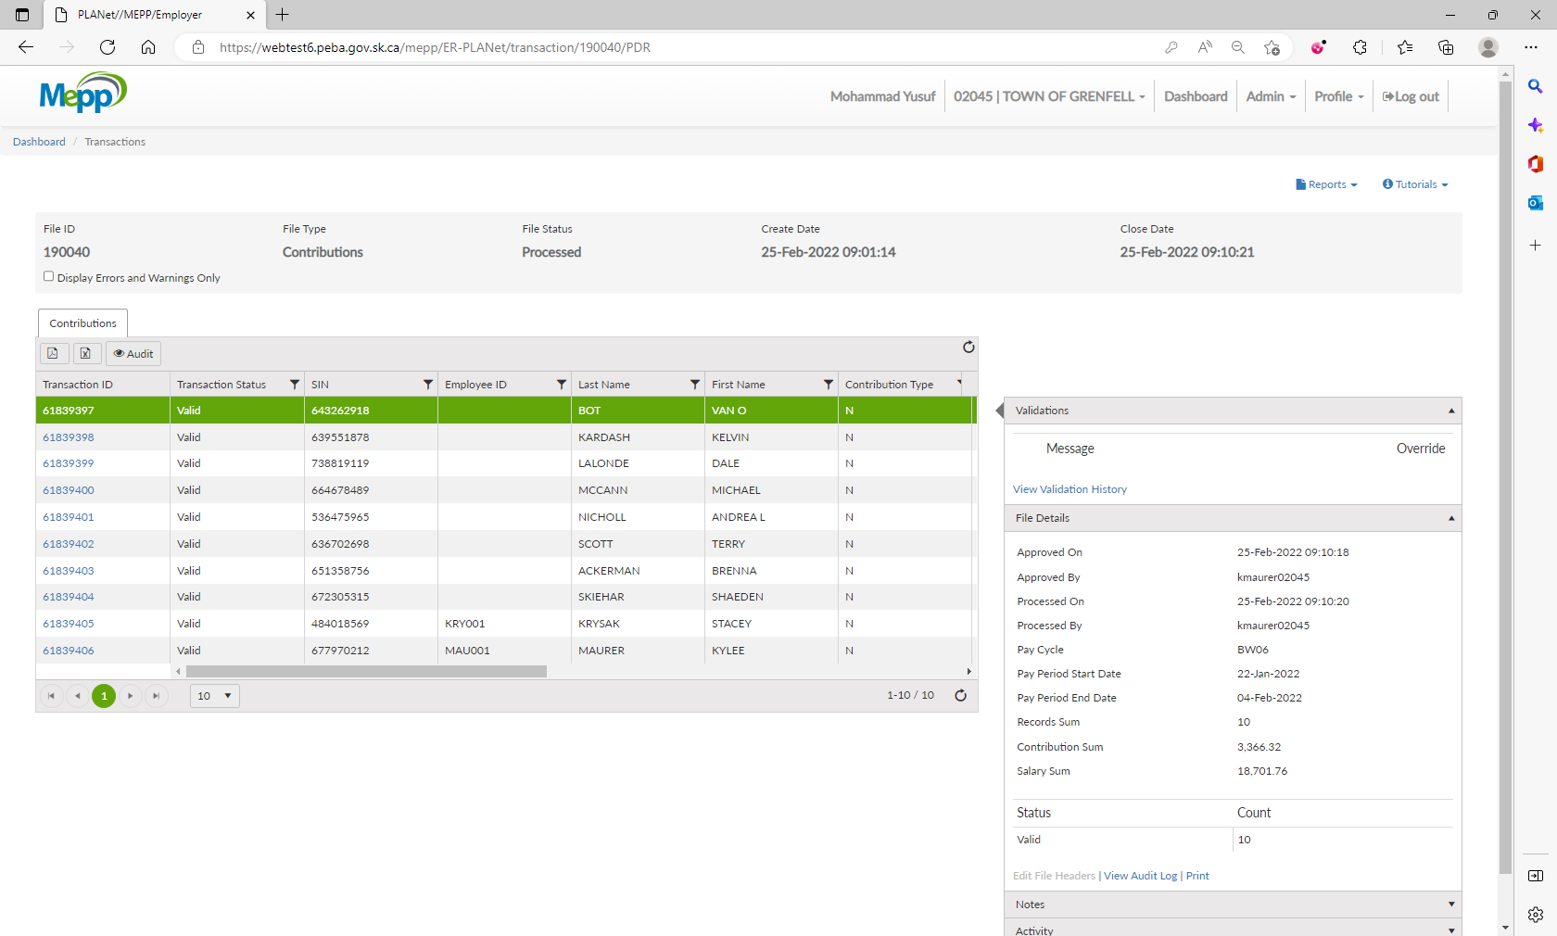

1. Click on Reports.

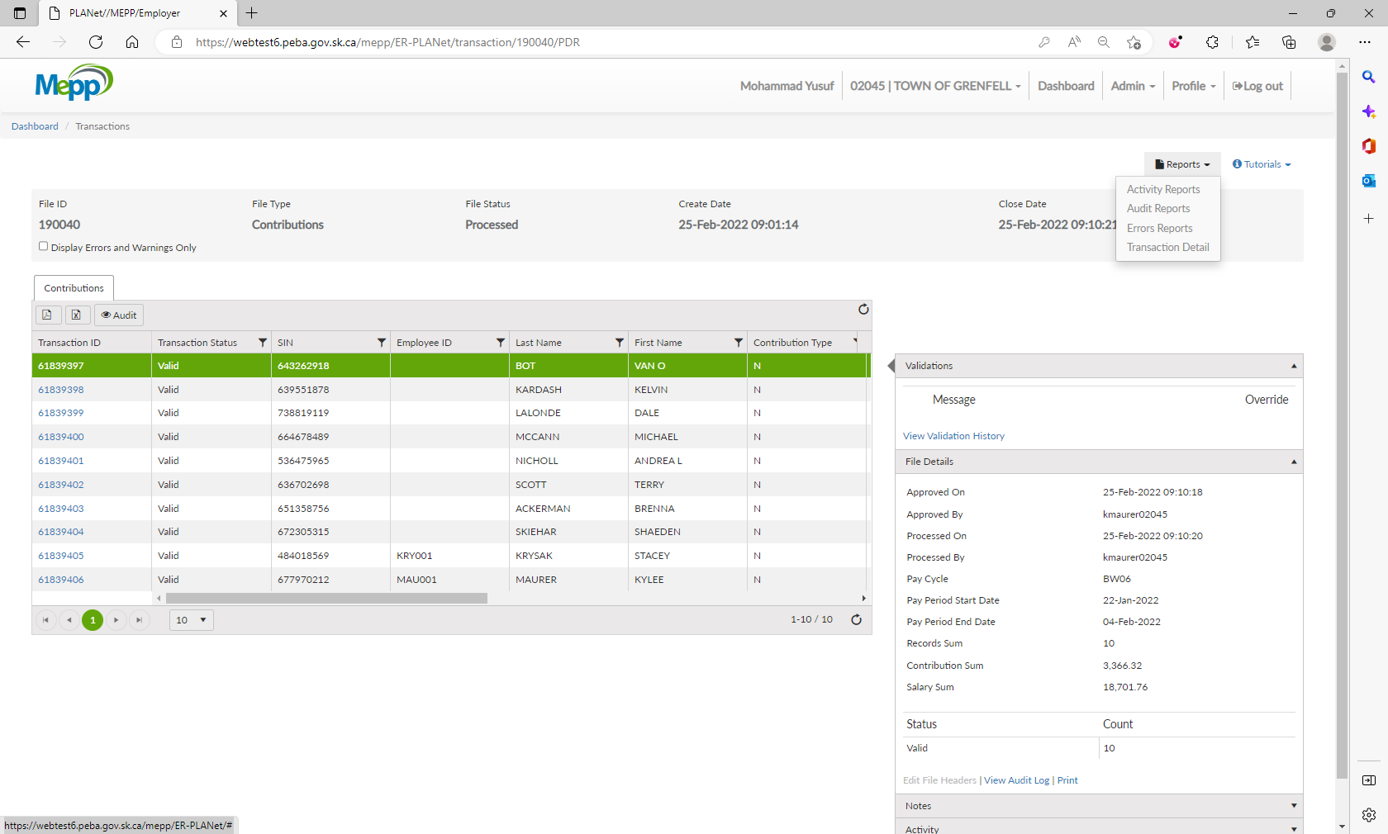

1. Select Errors Report from the dropdown.

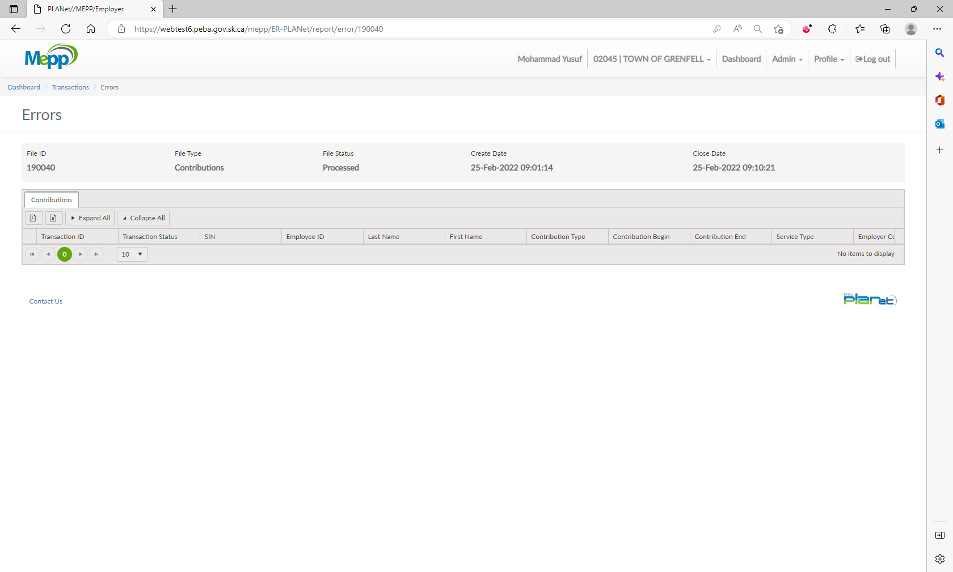

Can not validate the Error report as there were no errors in the above processing.

Created a new filetype to validate the Error report

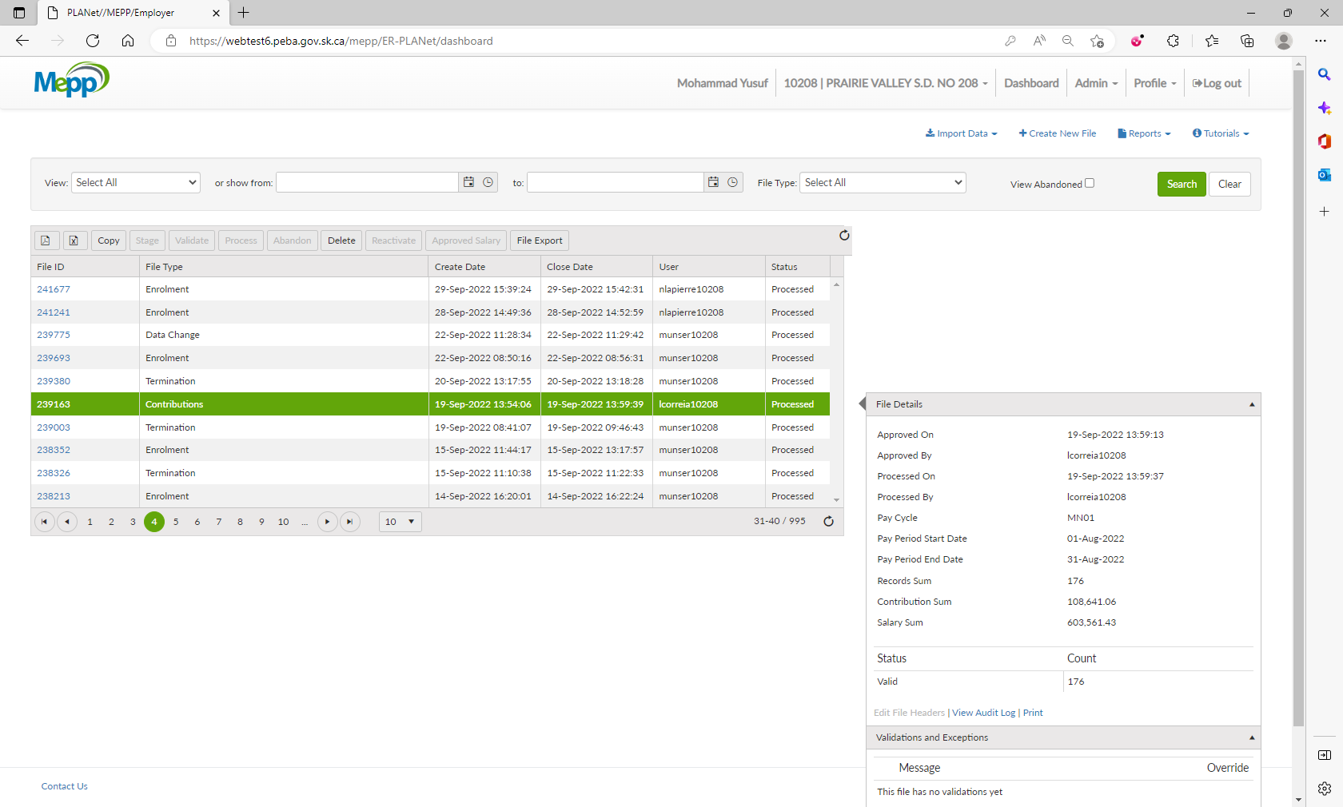

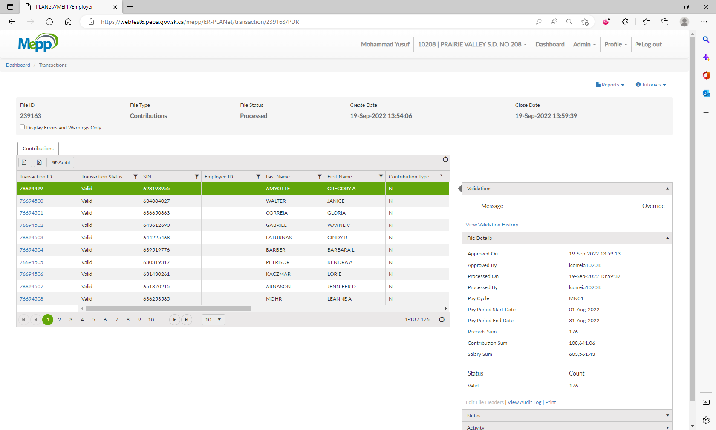

1. Errors Report -> You can see the details of each error by expanding it. Modified the report header

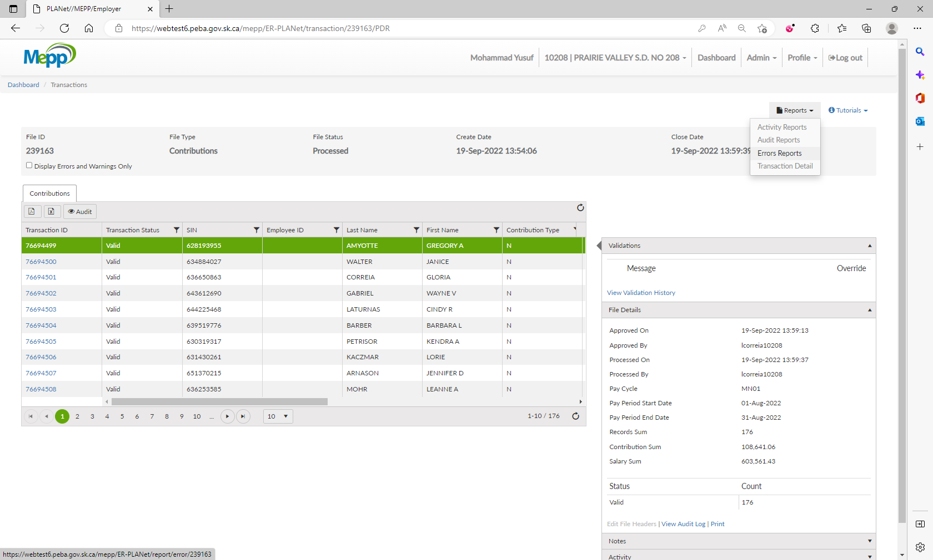

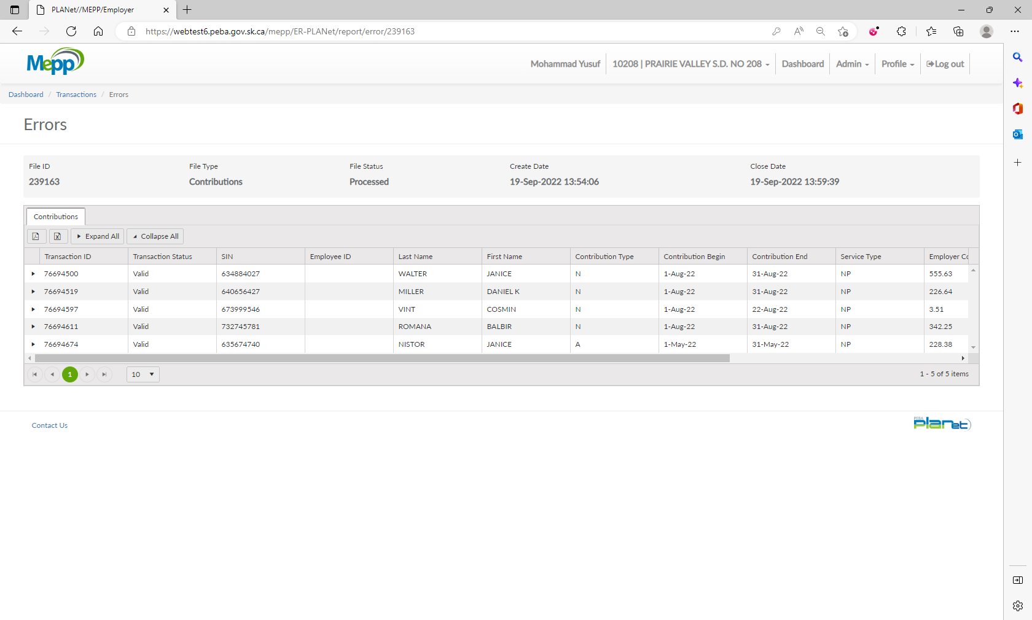

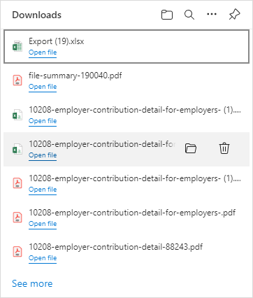

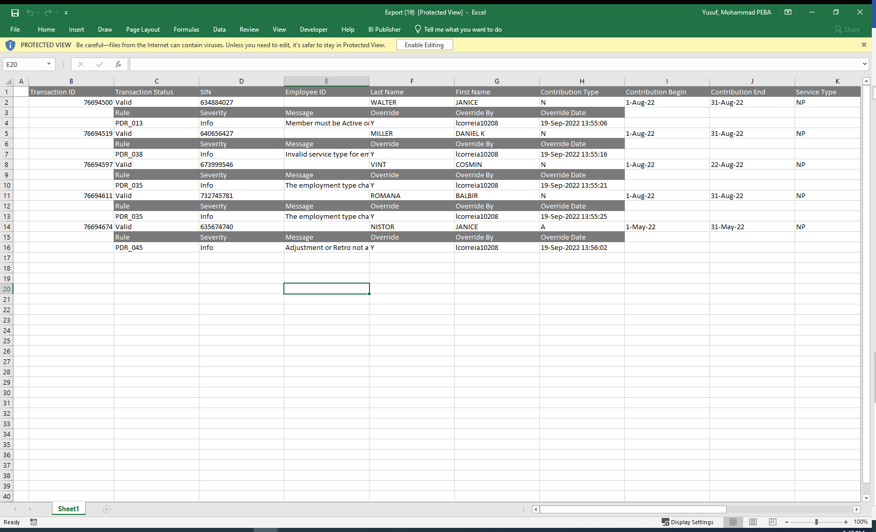

1. Click on Export to Excel. - Pass
2. Click on Export to PDF.

